# MED D - ScriptSync

General Information

ScriptSync Process

FAQs

Related Documents

**Description:** This document provides information on ScriptSync.

|  |
| --- |
| General Information |

ScriptSync® is a pharmacy capability from CVS Health that aligns a beneficiary’s maintenance medication fill schedule making it easier for them to stay on the therapies they need to effectively manage their conditions.

ScriptSync® offers beneficiaries the convenience to pick up multiple maintenance prescriptions in a single visit to their preferred CVS/pharmacy.

ScriptSync® also makes it easier for Caregivers to manage multiple medications for members of their family.

Top of the Document

|  |
| --- |
| ScriptSync Process |

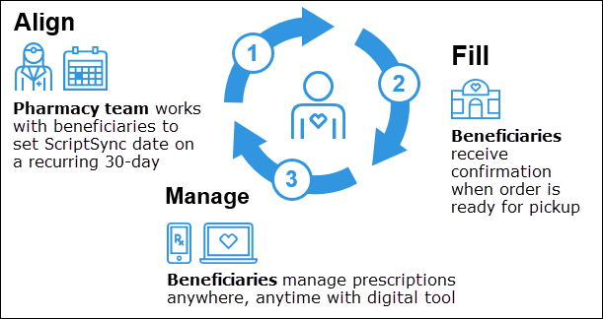

1. The CVS Pharmacy team works with the beneficiary to select eligible prescriptions and coordinate the alignment of fills on a recurring 30-day and/or 90-day schedule to meet the identified pick-up or delivery schedule. The Pharmacy team works in collaboration with prescriber(s) to ensure appropriate refills and renewal prescriptions are maintained.
2. The beneficiary receives confirmation when their order is ready for pickup.
3. The beneficiary can then manage their ScriptSync® prescriptions using digital support tools or get assistance from their pharmacy team.

**Note:** Once alignment of medications is complete, beneficiaries can pick up all refills in one pharmacy visit.

Top of the Document

|  |
| --- |
| FAQs |

Refer to the following:

|  |  |
| --- | --- |
| **Question** | **Answer** |
| 1. How can a beneficiary request ScriptSync®? | Beneficiaries and caregivers can request ScriptSync® in-person or by phone at their local CVS/pharmacy or online at [www.cvs.com](http://www.cvs.com). |
| 1. Is there a charge for this service? | No, this is a free service provided by CVS/pharmacy. |
| 1. How can a beneficiary manage their prescriptions once enrolled in the program? | Beneficiaries can manage their prescription information, add or remove prescriptions from their ScriptSync® order, and confirm their ScriptSync® pickup date either by contacting the pharmacy or online at [www.cvs.com](http://www.cvs.com). |
| 1. Will copays be adjusted? | Copays will be prorated if medication qualifies (not antibiotic, solid oral product, not dispensed in original container) and prescription is dispensed for less than the clients defined month supply. |

Top of the Document

|  |
| --- |
| Related Documents |

Grievance Standard Verbiage (for use in Discussion with Beneficiary) section in MED D - Grievances Index

**Parent SOP:** CALL-0049: [Customer Care Internal and External Call Handling](https://policy.corp.cvscaremark.com/pnp/faces/DocRenderer?documentId=CALL-0049)

**Abbreviations/Definitions:** Abbreviations / Definitions

Top of the Document

Not To Be Reproduced Or Disclosed to Others Without Prior Written Approval

**ELECTRONIC DATA = OFFICIAL VERSION – PAPER COPY = INFORMATIONAL ONLY**